1. What is the Nernst (equilibrium) potential of a monovalent cation (+ valence) at 37oC given the intracellular ion concentration is 10 mM and the extracellular ion concentration is 80 mM?
2. What is the resting membrane potential at 37 oC with relative permeability’s of PNa = 3, PK = 33 given the table below?

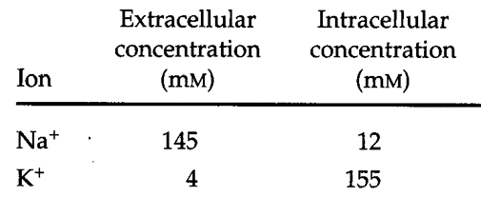

1. The two voltage wavefroms associated with the electroneurogram in Figure P3A differ in shape and size. The change in voltage shape with distance can be thought of as a low pass filter process, where a given distance along the nerve corresponds to one passage through a low pass filter, as shown in Figure P3B.

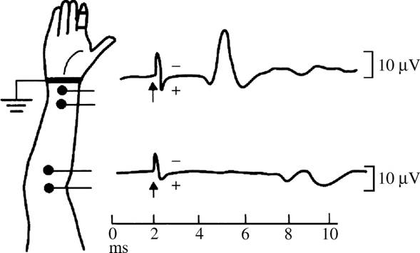

**Figure P3A.**

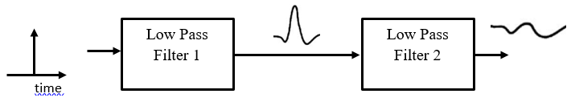

**Figure P3B**

1. If the initial stimulus is modeled as a delta function in time,

$$δ\left(t\right)=\left\{\begin{matrix}0 \text{if} t≠0 \\ ∞ \text{if} t=0\end{matrix}\right.$$

and if Filter 1 has a “boxcar” shape in frequency

$$H\left(jω\right)=\left\{\begin{matrix}1 \text{if} \left|\frac{ω}{2π}\right|≥1000 \text{Hz} \\ 0 \text{if} \left|\frac{ω}{2π}\right|>1000 \text{Hz}\end{matrix}\right.$$

what is a mathematical form for the output of the first filter? (Hint: You will need to review filter impulse responses from BIEN 225.)

1. Plot the output of the first filter as a function of time.
2. If the second filter has a shape $H\left(jω\right)$ and the input to this filter is $v(t)$, what is the mathematical relationship that you would need to evaluate to find the filter’s output?

**Graduate Content**

FFT and Fourier Series

I. In Matlab perform the following:

t=[0:1:200]; % Time in seconds

wt=2.*pi*0.005*t; % base frequency is 0.005 Hz

z=1 + cos(10*wt) + 0.5.*cos(20.*wt) + 0.25.*cos(30.*wt) + 0.125.*cos(40.*wt);

figure(1);

plot(wt,z);

b=fft(z);

c=b.*conj(b);

figure(2);

plot(c);

Answer the following questions:

1. What is the meaning of the variable “wt.” Why is it an appropriate variable to use in this program?
2. What is the time average of the signal z?
3. What does the line b=fft(z) do?
4. Why is it necessary to take abs(b)?
5. What is the x-axis in the plot of c?
6. The plot of c looks like a series of delta functions. Why?
7. What is the true frequency that corresponds to the x-axis value of 200 on the plot?
8. What is the true frequency that corresponds to the x-axis value of 180 on the plot?
9. Find the component that corresponds to the third term in the expression for z. What is the value of the peak of this component on the plot?
10. Why is the value of the peak of the third term peak not equal to ?

2. Now run the following Matlab code:

a=[0:1:400];

wt=2.*3.14159.*a/200;

z1=1 + cos(10*wt)+ 0.5.*cos(20.*wt) + 0.25.*cos(30.*wt) + 0.125.*cos(40.*wt);

z2 = 1+zeros(1,401);

a2 = [0:1:801];

wt2=2*3.14159*a2/400;

h1 = figure(1);

z = [z1 z2];

plot(wt2,z);

b=fft(z);

c=b.*conj(b);

h2 = figure(2);

plot(c);

1. At what x-axis value is the peak corresponding to the third term of z1 (i.e. $0.25\cos{(20ωt)}$) located?
2. Explain why the value is not the same as the value obtained with the first set of code.
3. What is the peak value of the peak corresponding to the third term of z1?
4. Explain why the peak value is not the same as it was with the first set of code.
5. Zoom in on the first non-DC peak (corresponding to cos(10*wt)) and describe its shape.
6. Explain why this peak has the shape that it does.
7. Find a mathematical expression that describes the spacing (in frequency) between the secondary peaks around the peak.
8. Find a mathematical expression for the peak values of the secondary peaks.
9. Print out the plots of (wt,z) and the plot of c, and turn these in with the answers to the above questions.

II. Use the Fourier series that represents a square wave, and write a program that **computes** and **plots** the first n terms of this expansion (where n is a variable that you will input when you call the function). You should be able to call this routine with the line:

>> squarewave(n);

With this routine, calculate and plot the n-term Fourier expansion of the square wave for n=1, n=2, n=10, n=100, and n=1000.

Turn in the plots for these five cases.

How many terms are needed to obtain a reasonable approximation of the square wave.

III. Modify the program you wrote in II above to calculate a triangle wave instead of a square wave.

1. Now how many terms are required to obtain a reasonable approximation of the triangle wave?
2. Why is this number so much smaller than the number of terms required for the square wave?

III. Consider the time series



If we take $ω=2π(200)$ and $k=10$, a plot of this function is shown in **Figure 1**.

**Figure 1: A 200 Hz signal that lasts over 10 cycles.**

1. To find the Fourier transform, directly integrate the Fourier transform definition. (Hint: Expand $e^{jωt}$ in the Fourier integral according to Euler’s rule. Then consider the $\cos{(ω_{0}t)}\cos{(ωt)}$ term and the $\cos\left(ω_{0}t\right)sin⁡(ωt)$ terms separately.one of these terms is odd, so the integral goes to zero. The other is even and can be rewritten according to a common trigonometric identity and then integrated directly.)
2. As an alternative way to find the Fourier transform, notice that the signal is the product of $\sin{(ωt)}$ and the pulse function that we have already transformed in the handout



And take the convolution of these two transforms (i.e. convolve the delta function from the sine wave with the sinc function).

1. Comment on how the transform over this finite window differs from the transform of a cosine over an infinitely wide window.